Kimberly Roeten

CIS 445-01: Data Mining

October 17, 2017

Tutorial 1

1. A couple of the problems that I encountered during this tutorial was first of all the data sets that I needed for the tutorial. When creating the new library, entering the path to the directory was a bit confusing at first because it’s example involved the server machine users leading to the username and then the desktop. I followed that exactly instead of leading the new library I was creating to the files in the zip file that was provided beforehand. Once I realized that, everything made sense from that point forward. Another problem that I encountered but ended up figuring out for myself was how to select a specific transformation method for some of the interval variables in the transform variables node. I was confused on where to select method, as there was a dropdown box in the top left corner that also had a method option. But like I said, I figured out for myself where these dropdown menus were located so I could change the listed variables into log 10 and optimal binning. The main problem I encountered during this tutorial was the last SAS code node, where you had to enter specific code in order for it to run properly. I originally had <LIBREF> as the name, but thankfully the sticky notes that were added to the instructions hinted that a different name might work and after I implemented that, everything else in the project ran and worked. Some ideas that I have that could possibly improve this tutorial is to be more clear where certain things are located, because when students have no idea where to look it takes up more time, so more visuals are personally preferred, not to mention this tutorial was very tedious, so perhaps splitting the work up a little more in separate tutorial assignments and just building them on top of each other is preferred as well. On a scale from 1 to 10, the instructions of the tutorial were a 9. In terms of the overall usefulness in getting students such as myself acquainted with SAS EM 14.1, this tutorial was certainly a 10.

2a. 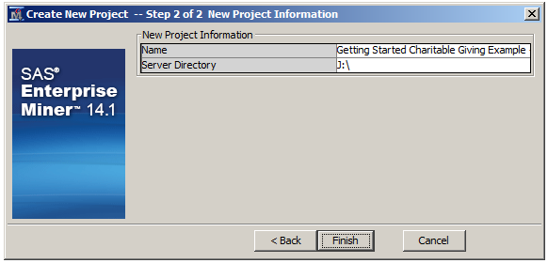

2b. 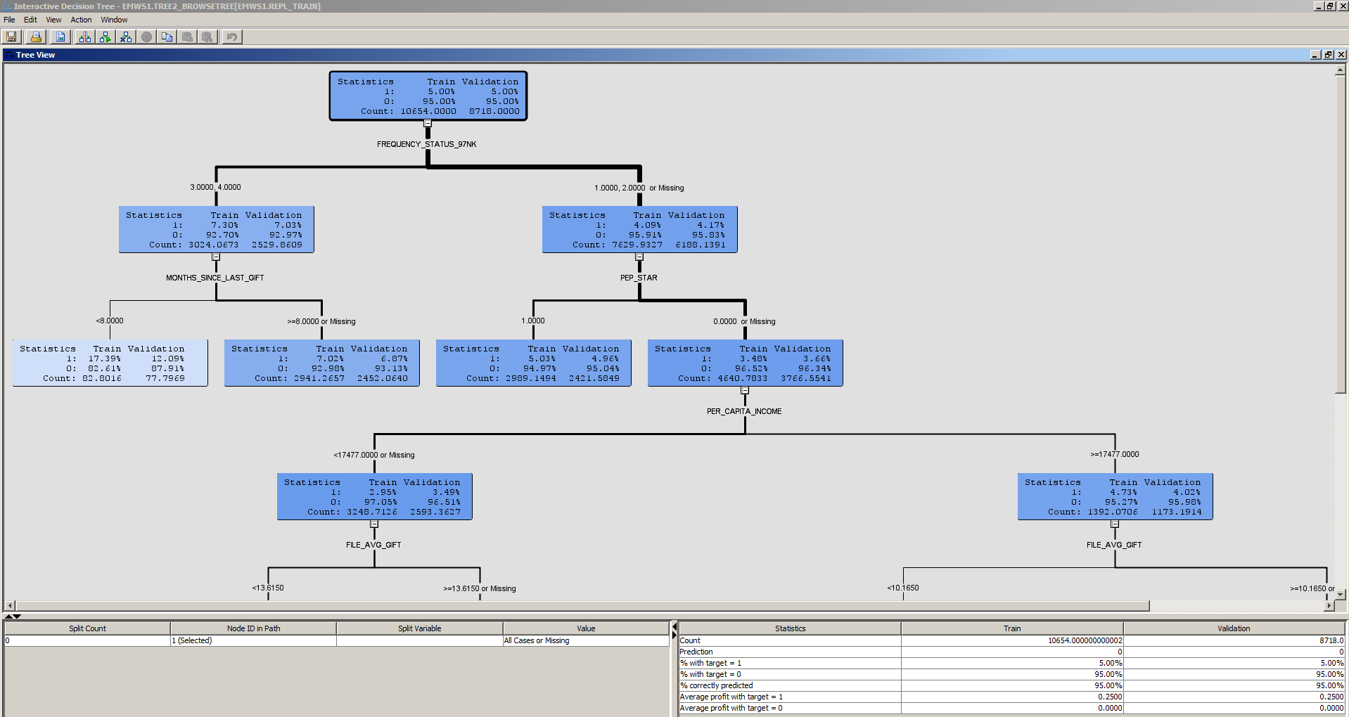

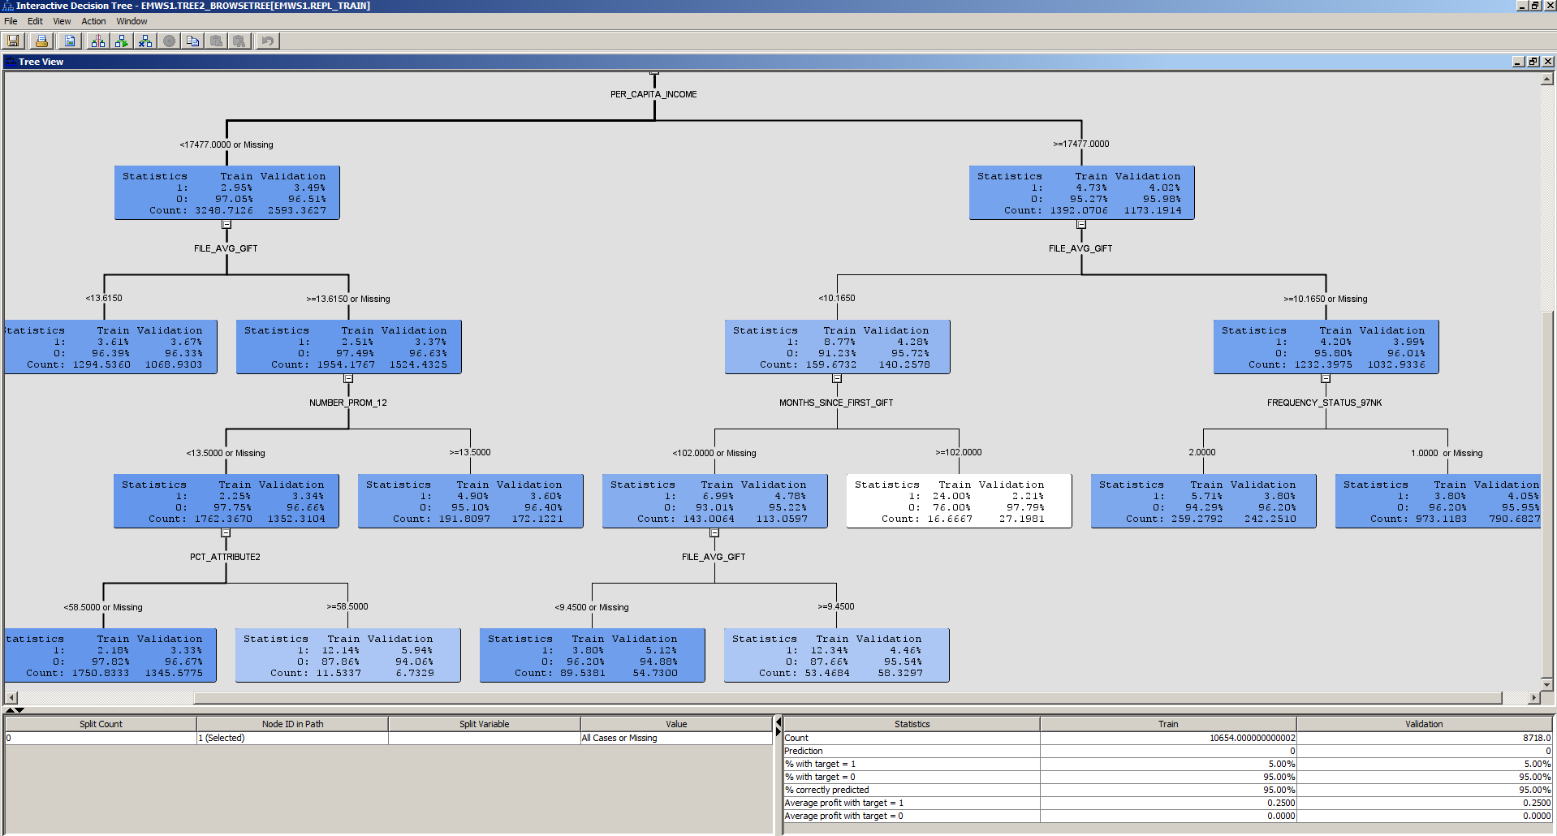

2c. 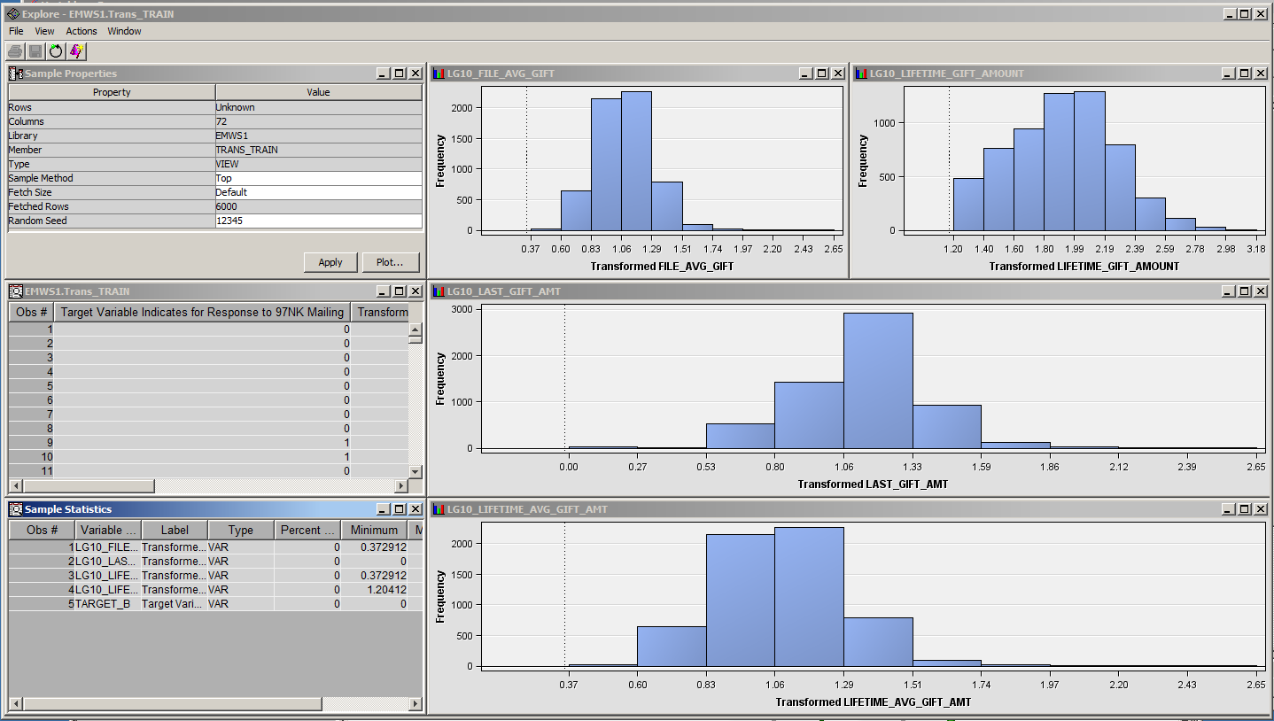

2d. 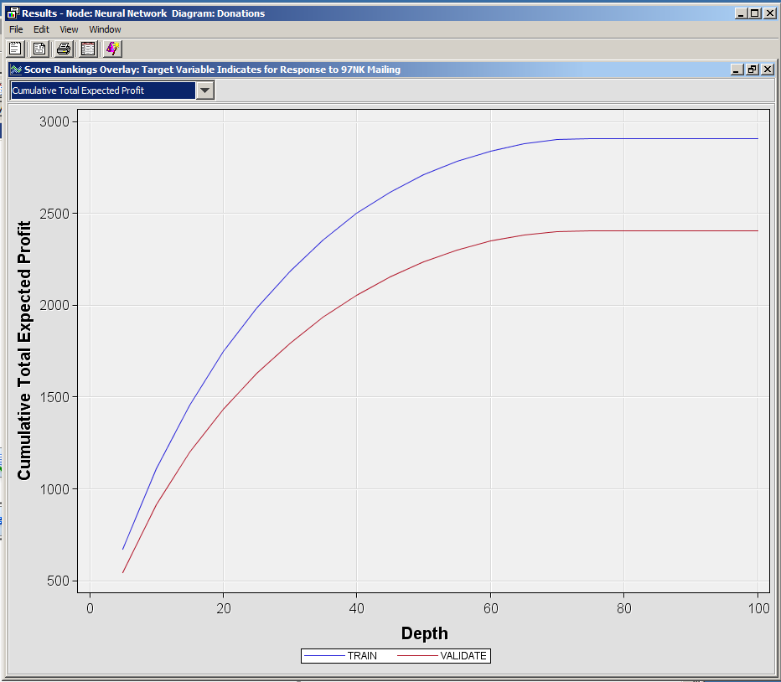

2e. 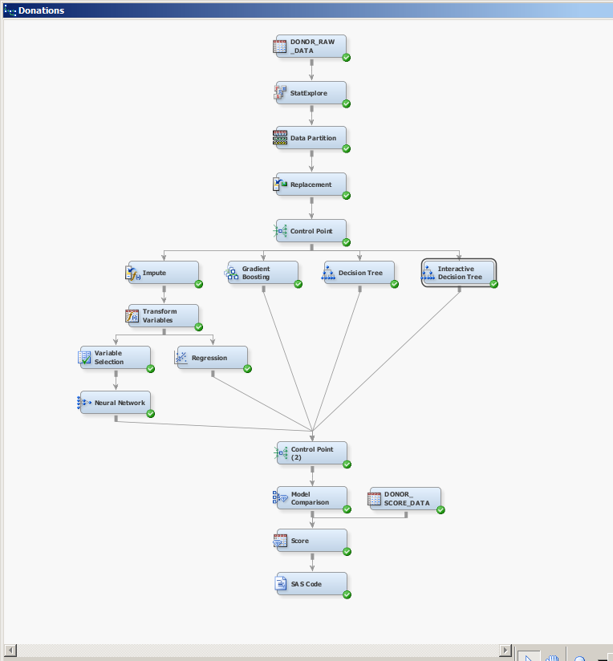

2f. 